E-COMMERCE WEBSITE

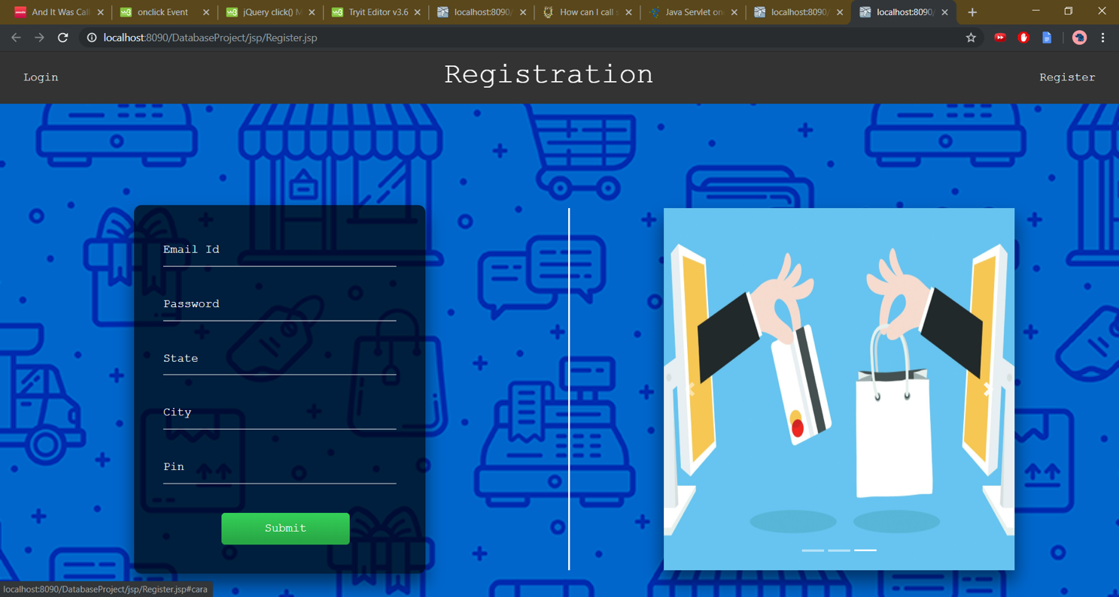

Akash Dubey Ayush Falor Preyas Hanche Navid Kagalwalla

*B026 B027 B034 B042*

*Btech Computer Btech Computer Btech Computer Btech Computer*

*Engineering Engineering Engineering Engineering*

**INDEX**

|  |  |  |
| --- | --- | --- |
| Sr.No | Topic | Page Number |
| 1 | Introduction | 3 |
| 2 | Project Specification | 4 |
| 3 | Software Used and Software Models | 6 |
| 4 | Analysis Modelling | 9 |
| 5 | Design Modelling | 22 |
| 6 | UI Design | 26 |
| 7 | Code Design | 33 |
| 8 | Cost Estimation | 38 |
| 9 | Test Cases | 40 |
| 10 | Project Team Management | 48 |
| 11 | Future Scope | 49 |

1. **INTRODUCTION**

e-Commerce, also known as e-Business, or electronic business, is simply the sale and purchase of services and goods over an electronic medium, like the Internet. eCommerce websites are online portals that facilitate online transactions of goods and services through means of the transfer of information and funds over the Internet.

e-Commerce has made shopping so convenient and easy, that anyone can shop for anything right from a living room, with just a few clicks. This has evolved more with the emergence of smartphones, where now, you can shop from anywhere and anytime, with a wireless device connected to the Internet. Now you can search for almost any product or service online, without having to go anywhere physically.

To facilitate easy, seamless shopping over the internet we decided to make an e-Commerce website as our project.

1.1 PROBLEM STATEMENT –

E-Commerce Website which

1. Allows users to easily buy products of various categories.
2. Allows vendors to sell their products directly to customers.
3. Provides a platform to connect buyers and vendors.

1.2 BASIC UNDERSTANDING OF THE PROBLEM –

An e-commerce website makes the buying of products easy and hassle free. Users can buy a product online through secure means and have it delivered to their doorstep. To make this happen, an easy to use website is what we aim to make. We need a selection interface that allows users to go through the selection of products offered. We also need to develop an easy interface for vendors from which they can put products up for sale along with the product’s description. Admin rights will be there for super users who check legitimacy of the product and users.

1.3 PEOPLE WHO WANT A SOLUTION –

The stakeholders (in this case us) want to make this project since buying habits are changing and users widely use websites to buy products without the hassle of going to a store physically. Buyers as well as vendors also need this solution since this provides a platform to connect them effortlessly.

1.4 NATURE OF THE SOLUTION –

We aim to make an easy to use website in which every journey is small and hassle free. Further we want to provide secure and seamless transaction since security is paramount. The database of the products should also be dynamic and up to date. Admin rights should be higher than users. New vendors and users should be easily added. Existing vendors should be able to put products up for sale in real time. The software made should be re-usable and easily maintainable since new business requirements and extensions may be needed in the future.

1.5 GOAL AND OBJECTIVE –

The goal of making this e-commerce website is to provide a one-stop easy to use shopping site for users and vendors. By making this website, we aim to understand the various software engineering steps, processes, principles and guidelines which must be followed to help make a software a success.

1.6 PRODUCT DESCRIPTION –

The e-commerce website contains the front-end and back-end. The front-end contains various UIs such as login, registration, buyer view, vendor view and admin view. The back-end contains the database with multiple tables which store data which can reflect data changes in real time. The product is made with a view to provide value to the users by helping them buy products with ease.

1. **PROJECT SPECIFICATION**

Requirements identification is the first step in our e-commerce website development. Until the requirements have been clearly identified, and verified, no other task (design, coding, testing) can begin.

Requirements engineering refers to the process of understanding what a customer expects from the system to be developed, and to document them in a standard and easily readable and understandable format. This documentation will serve as reference for the subsequent design, implementation and verification of the system.

It is necessary and important that before we start planning, design and implementation of the software system, we are clear about its requirements. Requirements must be unambiguous, complete and consistent.

The requirements we use can be classified as:

2.1 FUNCTIONAL REQUIREMENTS (FRS)

These describe the functionality of a system -- how a system should react to a particular set of inputs and what should be the corresponding output.

The functional requirements in our project are:

• User – Friendly UI

The user interface must be easy to use and each journey must end with some logical conclusion. Further, the output produced should be consistent and comprehensible to the user. The amount of information being shown to the user should be limited so that the user is not overwhelmed.

• Profile Login/Registration

The user must be able to log in if he already has an account or be able to sign up if he/she is a new user. The Registration page must take email, username and password and this should be verified at the backend so that no two accounts with the same email exist. The Login should take username and password only after verifying the database. Forgot password feature must also be enabled.

• Admin Access

Administrator Rights must be given to a super user who checks the legitimacy of products and users. Also admin monitors the website for faults and sees the real time data shown to the users.

• Listing of Products

Products should be listed and shown to customers to help them purchase. Products should be listed category-wise and only those products which are in stock should be shown to the user.

• Different Views to Users/Admin

A normal user shouldn’t be given the same privileges as an admin and shouldn’t be able to alter the website since this could cause security concerns.

• Logout Functionality

On completion, users should be able to log out from their account but their data such as orders placed or items saved in cart must remain.

2.2 NON-FUNCTIONAL REQUIREMENTS (NFRS)

They are not directly related to functionalities that are expected from the system. However, NFRs could typically define how the system should behave under certain situations.

The non-functional requirements in our project are:

• Advanced Security On the Internet

The website should be secure and immune to attacks. The website should use encryption such as SHA-256 for password to help accounts be protected. Also, since payments can be made online to buy products, the payment gateway on our website should use up to date security measures like SSL protocols, tokenization, anti-fraud tools etc.

• Robust Servers

The servers used to host the website should be able to take varying degree of load. On certain days the number of users may be more as compared to others. Cloud services such as AWS can also be used to improve storage and load bearing capacity.

* Networking Facilities

Internet must be present for users to access the website and buy products.

• Smooth Flow of Data across the entire website

The entire website should not lag and download easily. The payment gateway should not lag and process the funds fast. The aesthetics should not be compromised to ensure the smooth flow of entire website. Data flow from one webpage to another should be seamless and data integrity must be ensured.

* Compatibility on Devices

The website should be compatible on various devices such as mobile, desktop etc. The aesthetics and ease of use of website must not change even if the device changes.

1. **SOFTWARE USED AND SOFTWARE MODELS**

3.1 SOFTWARES USED

The softwares used in the development of our website were decided after considering re-usability, maintainability, risk and the quality assurance of our project. We used the following softwares:

* GitHub
* Java
* HTML
* PHP
* JavaScript

3.2 SOFTWARE MODELS USED

A software process as a framework for the activities, actions and tasks that are required to build high-quality software. The generic process model consists of activities—communication, planning, modeling, construction and deployment.

While deciding the software models to use we first identified the task set for our project. A task set is the actual work to be done to accomplish the objectives of a software engineering action. The task set requirements gathering included:

* Making a list of stakeholders for the project
* Building a preliminary list of functions and features for the website
* Produce informal user scenarios when they use the website
* Building a list of constraints and restrictions

After deliberation we decided on a Hybrid Type of model for the project as it includes multiple modules where each module has a different timeline (duration).

* Registration and Login Page –

For our login and registration page, we have chosen Spiral process model. The spiral model combines the idea of iterative development with the systematic, controlled aspects of the waterfall model. This Spiral model is a combination of iterative development process model and sequential linear development model i.e. the waterfall model with a very high emphasis on risk analysis. It allows incremental releases of the product or incremental refinement through each iteration around the spiral.

The login and registration pages go through constant change as security requirements of login and registration page must be updated frequently. Also, the aesthetic of the page may be changed to look better. The base language in which the web pages were coded in may change due to security concerns or because another language can portray the features better. The input taken from the user may change to include another field, for example Captcha.

The first iteration for the login and registration webpage using Spiral Model:

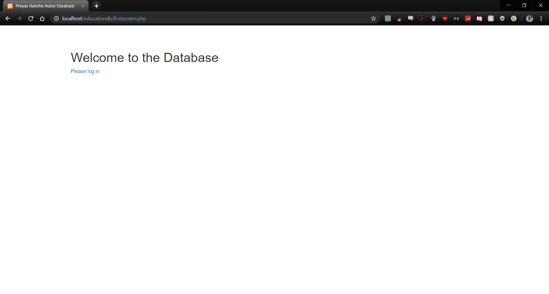

Fig No. 3.1: Spiral Model Use

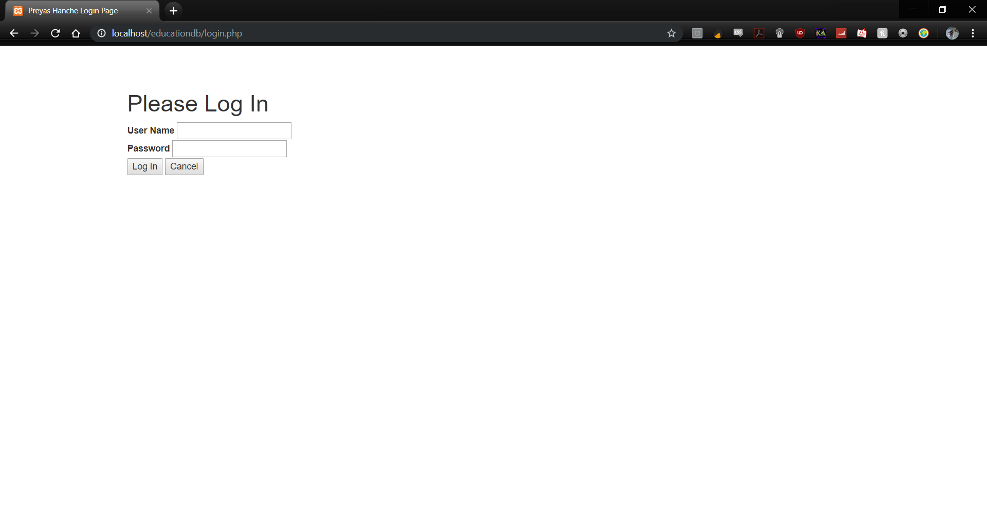

Fig No. 3.2: Spiral Model Use

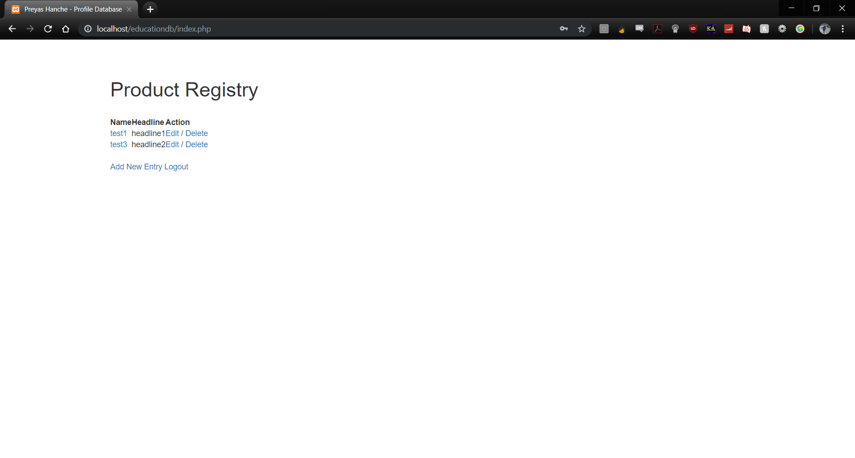

Fig No. 3.3: Spiral Model Use

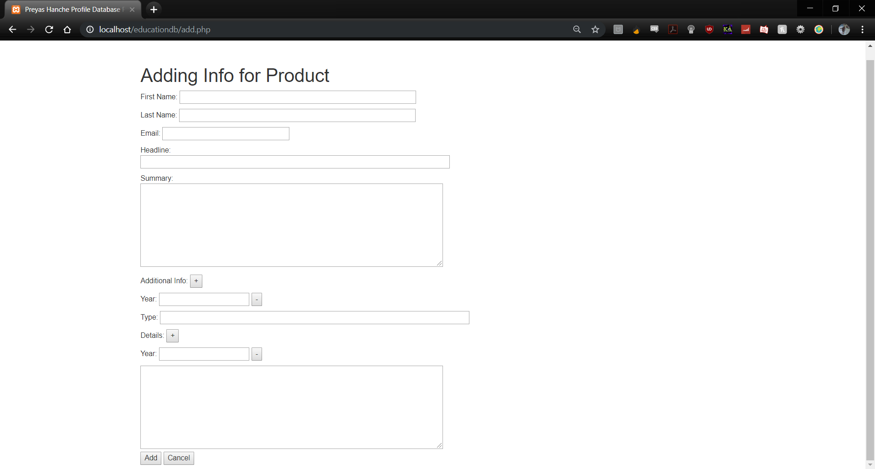

Fig No. 3.4: Spiral Model Use

The first iteration included the following points:

* In the first iteration of spiral model in the case of Login and Registration pages, the team had decided to go with PHP as its base language.
* After discovering multiple inconsistencies and issues related to cookies and sessions as well as GET and POST requests, the team decided to go along with Java as its base language.
* Thus, in the next iteration of Spiral Model a better base of code for Login and Registration pages were made using Java.
* No frontend was added in the first iteration hence it saved time in getting the basic functionality of these webpages out to test to the user.
* All the existing features were ported to the Java edition, hence there was no loss in functionality.
* User Profile and Buyer View –

For User Profile we have chosen a Spiral Model. The spiral model is an evolutionary software process model that couples the iterative nature of prototyping with the controlled and systematic aspects of the waterfall model. It provides the potential for rapid development of increasingly more complete versions of the software.

The profile modules go through constant change and must be as secure as possible as any changes made should be verified and a log of them must be kept. Also, the details of each user varies drastically and the products they buy or “look-through” depend on it. Although this model is more expensive but security and proper aesthetic is paramount to the website and thus must be used.

For the buying module, we have chosen Agile Model. The Agile Model is a collection of values, principles, and practices for modeling software that can be applied on a software development project in an effective and light-weight manner.

The buying module is critical to the e-commerce website since users buy all the products from this module. The buying module is the main source of revenue for the e-commerce website and thus should be beyond user expectations in terms of the user interface (user friendliness) and ease of journey. The Agile Model helps achieve this and at the same time helps meet deadlines.

* Vendor view –

For selling products on the website, we are using a RAD Model as this model helps to mitigate risks and required efforts on the developer parts. This model helps clients to take quick reviews for the project. This methodology encourages customer feedback which always provides improvement scope for any software development project. Since the seller should be comfortable with how his/her product looks on the website, his feedback is important. RAD Model helps the module be developed within a short time frame (2-3 months). RAD is flexible and adaptable to changes. This helps in the case of adding new products and sellers. The website should go live within a certain time frame to meet deadlines. Also, changes made should be done in a smooth and easy manner. For example, if a new seller wants his/her items to be put on the website so that users can buy from it; this addition should be done in a fast way so that the backend and the website can now show the users this newly available products from this particular store owner. Since our team is small, RAD helps in an increase in productivity and output. In each phase RAD delivers highest priority functionality to the client and since putting the products of the seller on the website is the most important revenue source of the website, developing this first will be the aim.

* Admin and Security Payment –

Security is the most important functionality of any website, without security user won’t trust the website completely, hence we use Spiral Model. Spiral will regularly test, analyze and find better ways to improve security. A software is never truly secure and hence the security has to be constantly upgraded and updated to ensure that all new threats that come up can be effectively dealt with. With constant upgrades and constant development we can ensure dynamic security for our software.

**ANALYSIS MODELLING**

The intent of the analysis model is to provide a description of the required informational, functional and behavioural domains for a computer-based system. The model changes dynamically as you learn more about the system to be built, and other stakeholders understand more about what they really require.

The analysis modelling involves

SCENARIO BASED ELEMENTS

The system is described from the user’s point of view using a scenario-based approach (use cases).

* The use case for the Login and Registration Page:

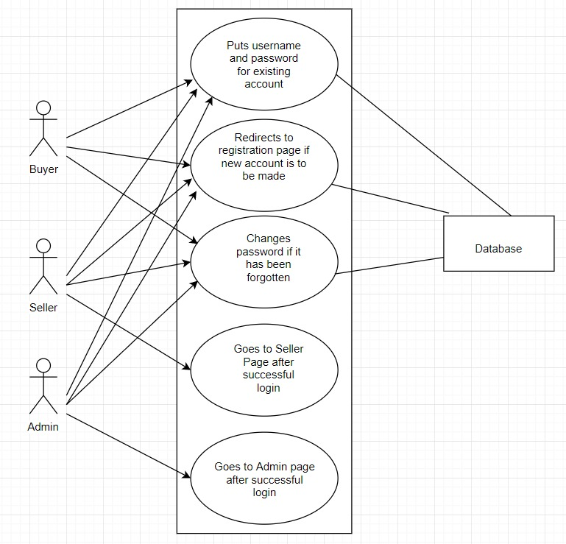

Figure 4.1: Use Case for Login and Registration

* The use case for the Vendor Page:

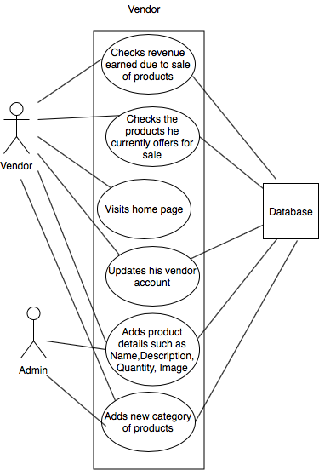

Figure 4.2: Use Case for Vendor

* The use case for the Buyer Page:

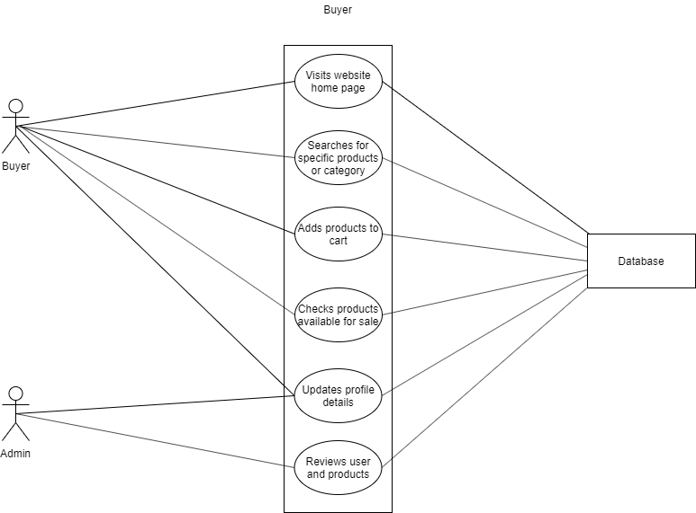

Figure 4.3: Use Case for Buyer

* The use case for the Admin Page:

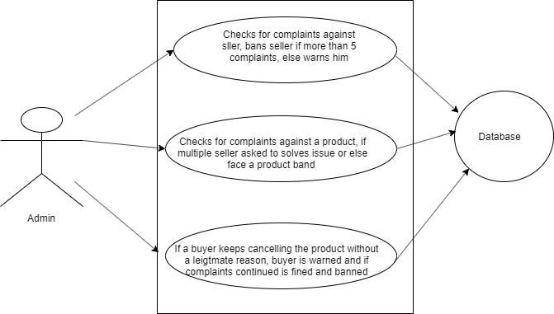

Figure 4.4: Use case for Admin

CLASS BASED ELEMENTS

Each usage scenario implies a set of objects that are manipulated as an actor interacts with the system. These objects are categorized into classes—a collection of things that have similar attributes and common behaviors (class based diagram)

* The class based diagram for Login and Registration page including classes:

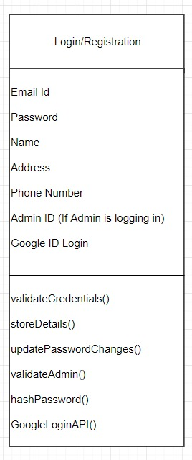

Figure 4.5: Login/Registration

* The class based diagram for Vendor page including classes:

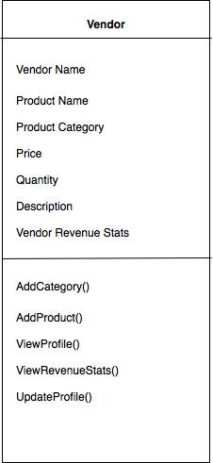

Figure 4.6: Vendor

* The class based diagram for Buyer page including classes:

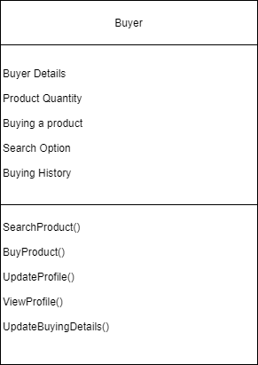

Figure 4.7: Buyer

* The class based diagram for Admin page including classes:

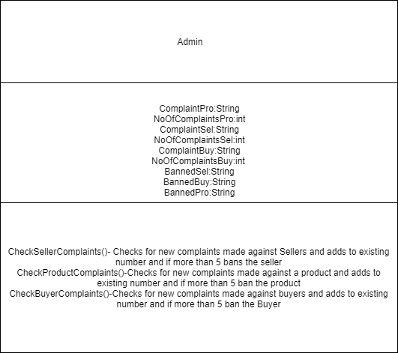

Figure 4.8: Admin

BEHAVIOURAL ELEMENTS

The behaviour of a computer-based system can have a profound effect on the design that is chosen and the implementation approach that is applied. Therefore, the requirements model must provide modelling elements that depict behaviour (state diagram).

The main purposes of using State chart diagrams −

* To model the dynamic aspect of a system.
* To model the life time of a reactive system.
* To describe different states of an object during its life time.
* Define a state machine to model the states of an object.
* The behavior diagram for Login and Registration Page includes dynamic aspect and state of the machine.

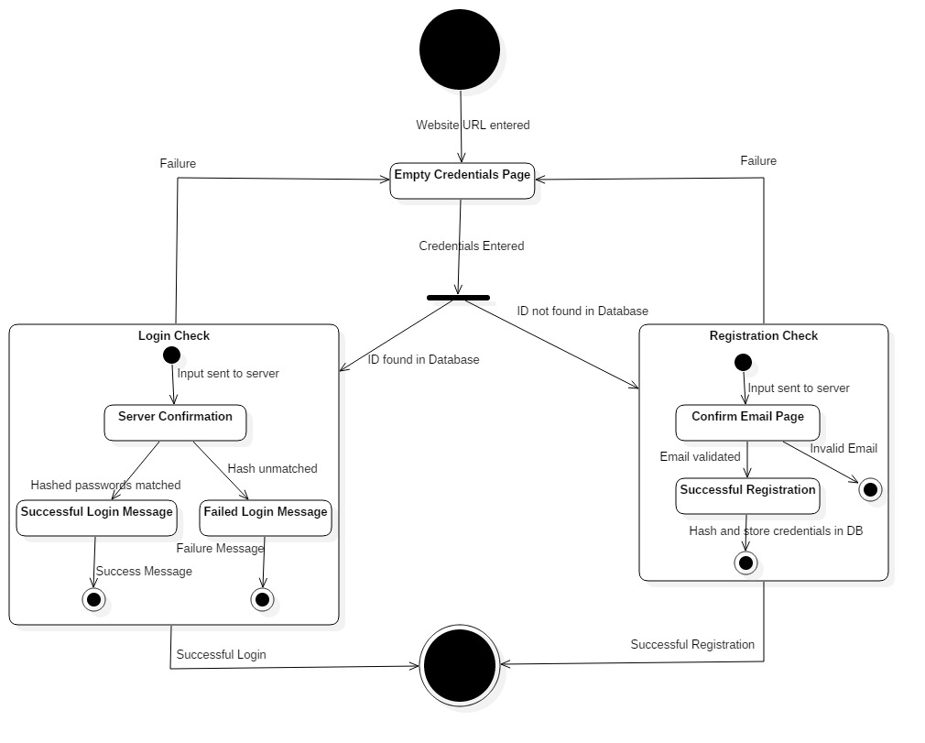

Figure 4.9: Login and Registration

* The behavior diagram for Selling Page includes dynamic aspect and state of the machine.

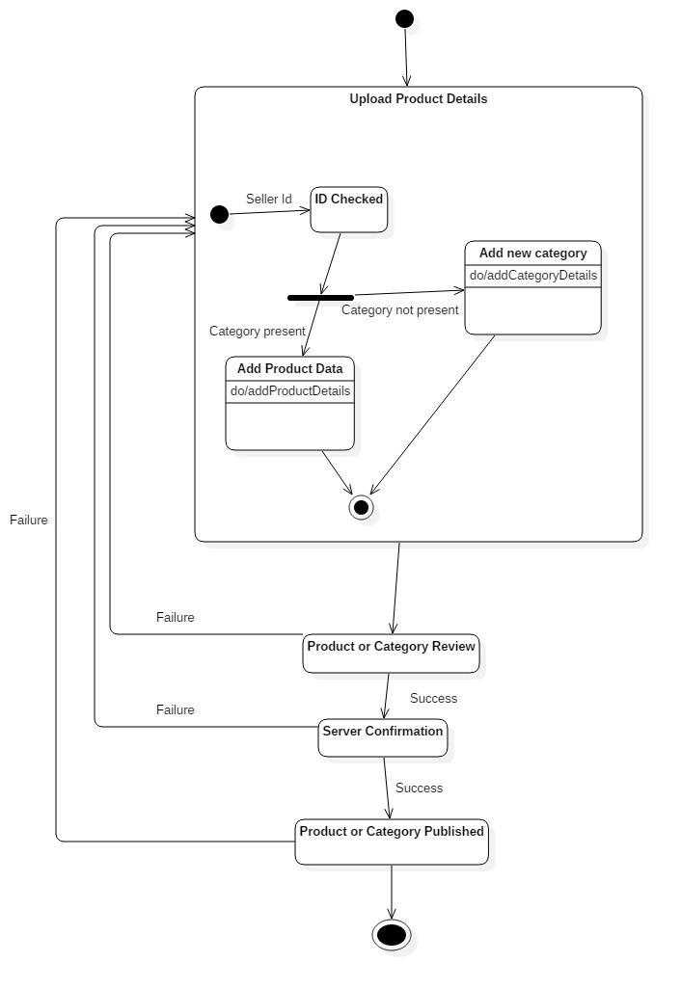

Figure 4.10: Selling

* The behavior diagram for Buying Page includes dynamic aspect and state of the machine.

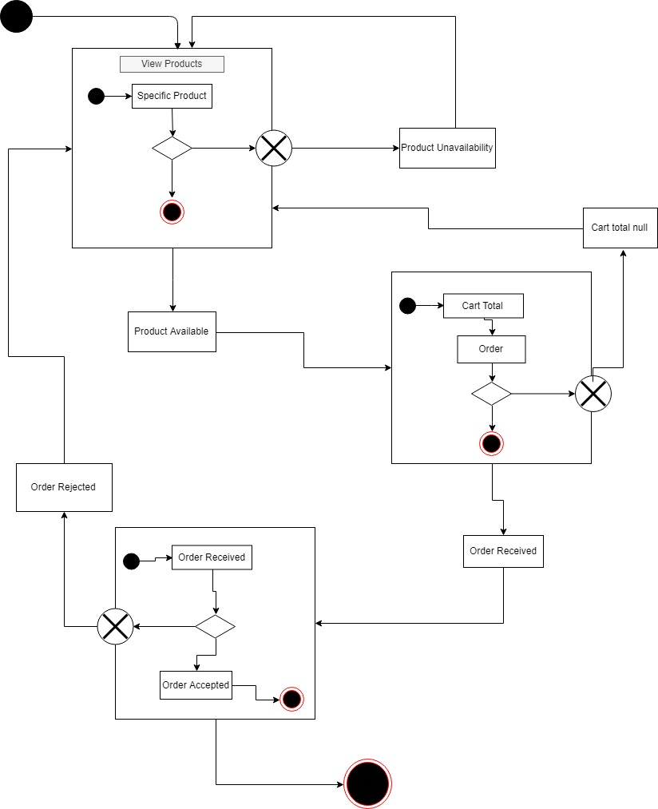

Figure 4.11: Buying Page

* The behavior diagram for Security/Admin includes dynamic aspect and state of the machine.

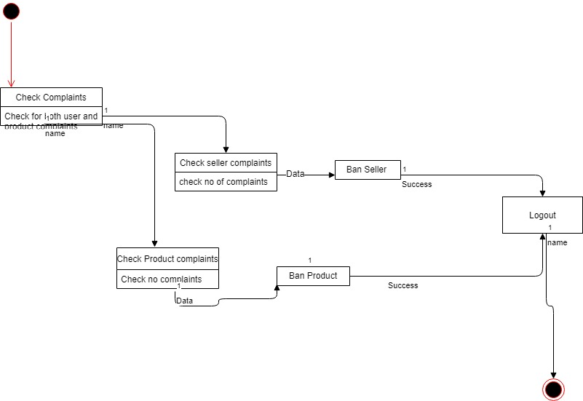

Figure 4.12: Security and Admin

FLOW ORIENTED ELEMENTS

Information is transformed as it flows through a computer-based system. The system accepts input in a variety of forms, applies functions to transform it, and produces output in a variety of forms (data flow diagram).

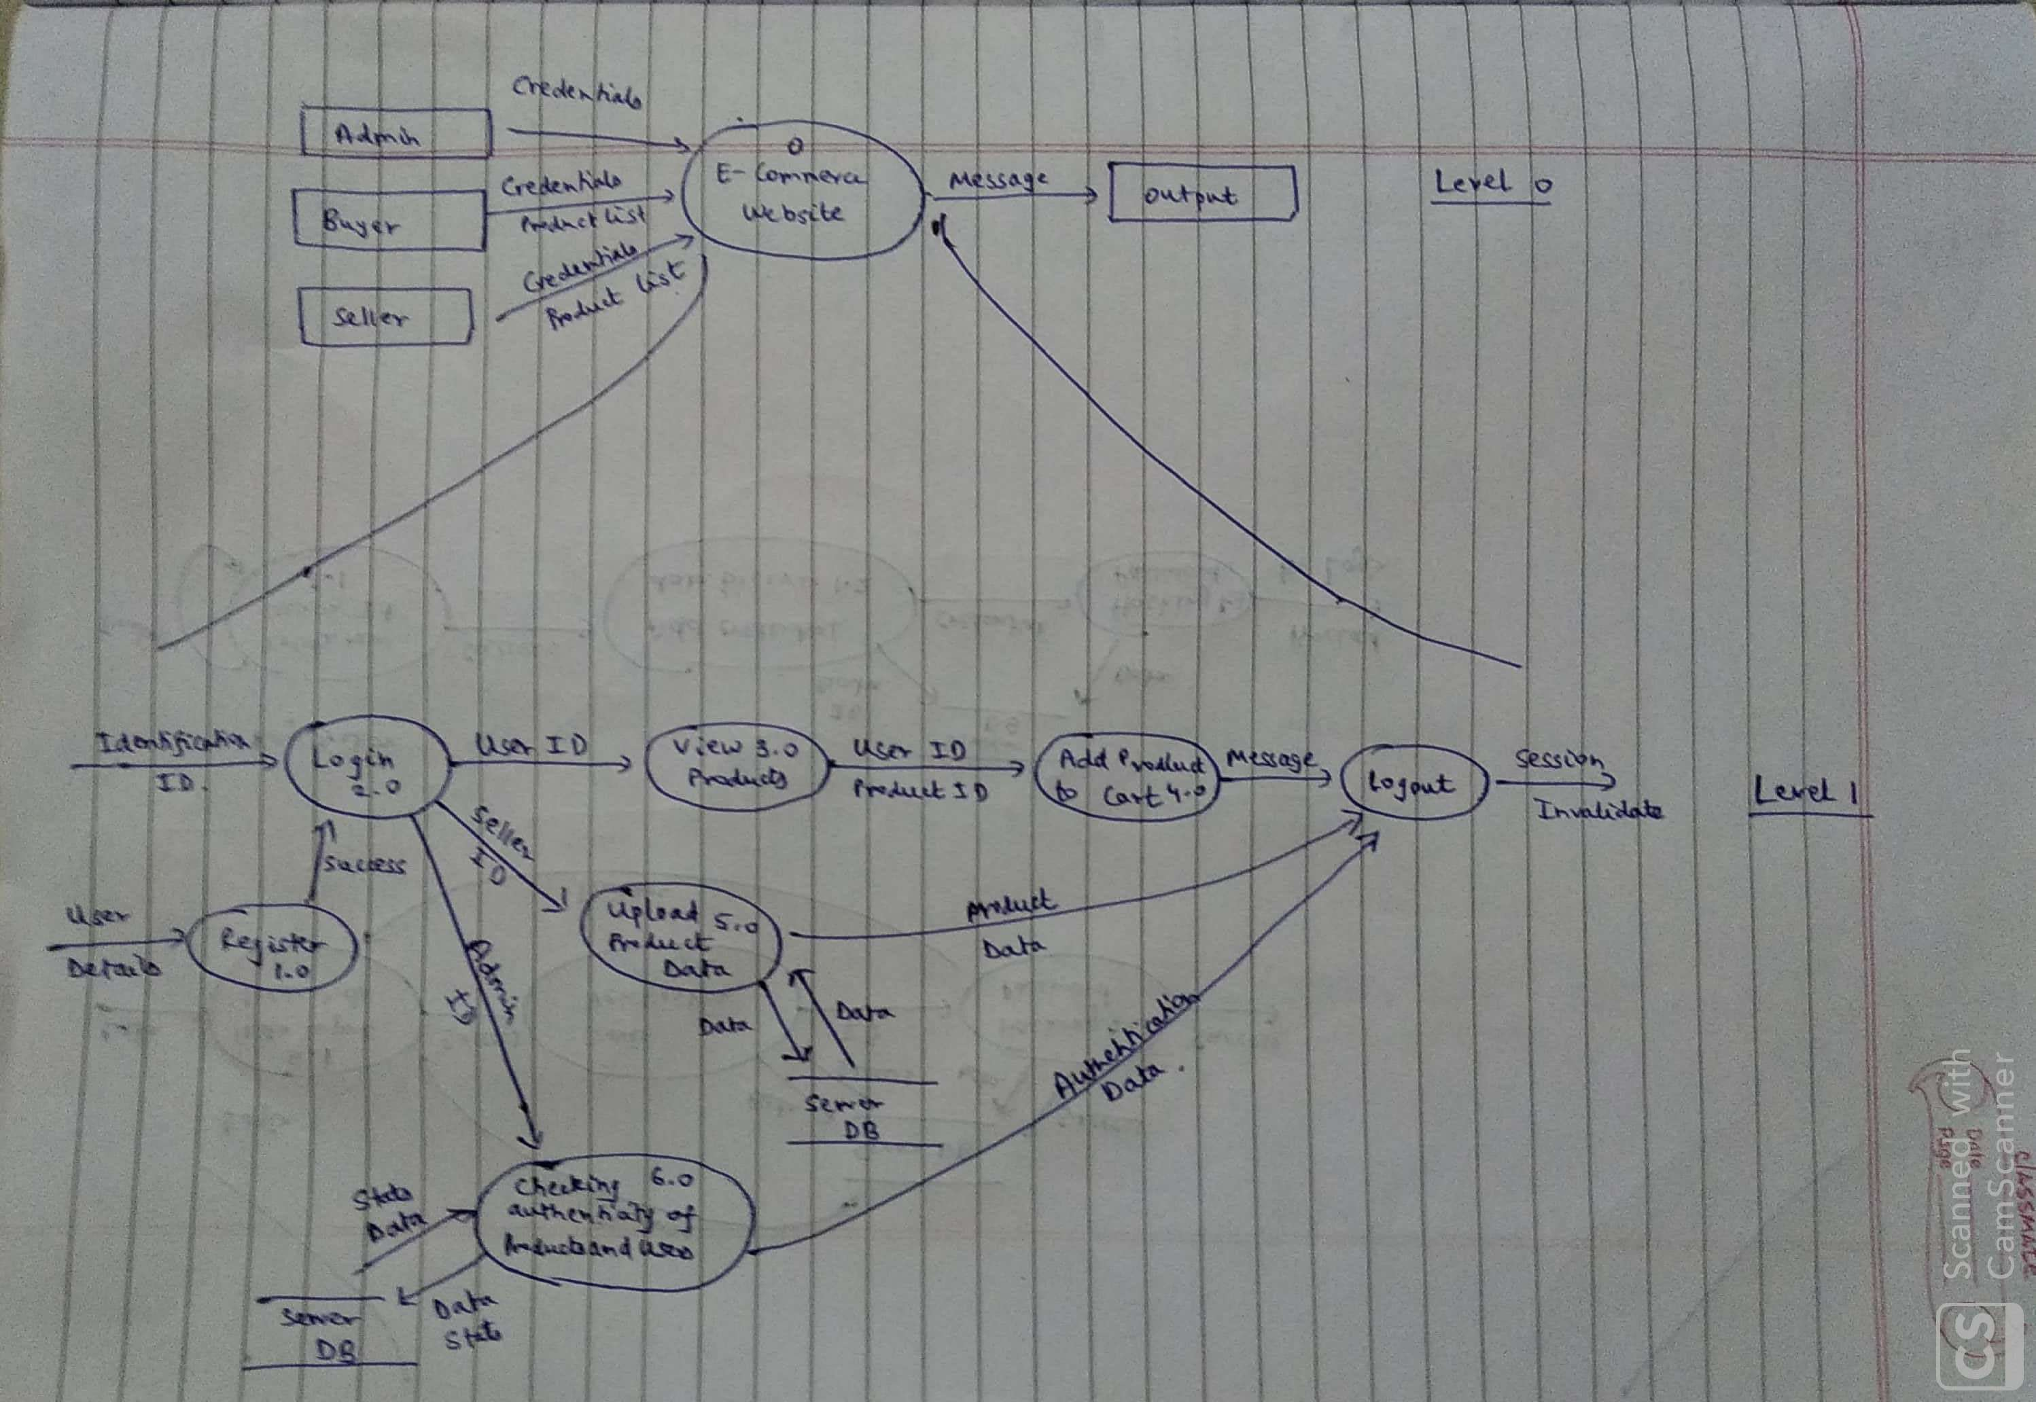

Figure 4.13: Level 0 and Level 1 of DFD

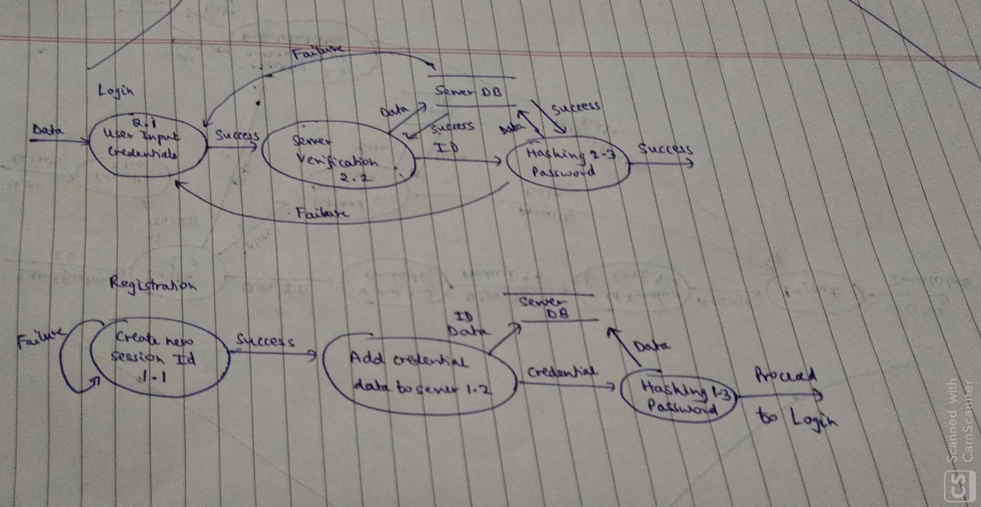

Figure 4.14: Level 1 of DFD

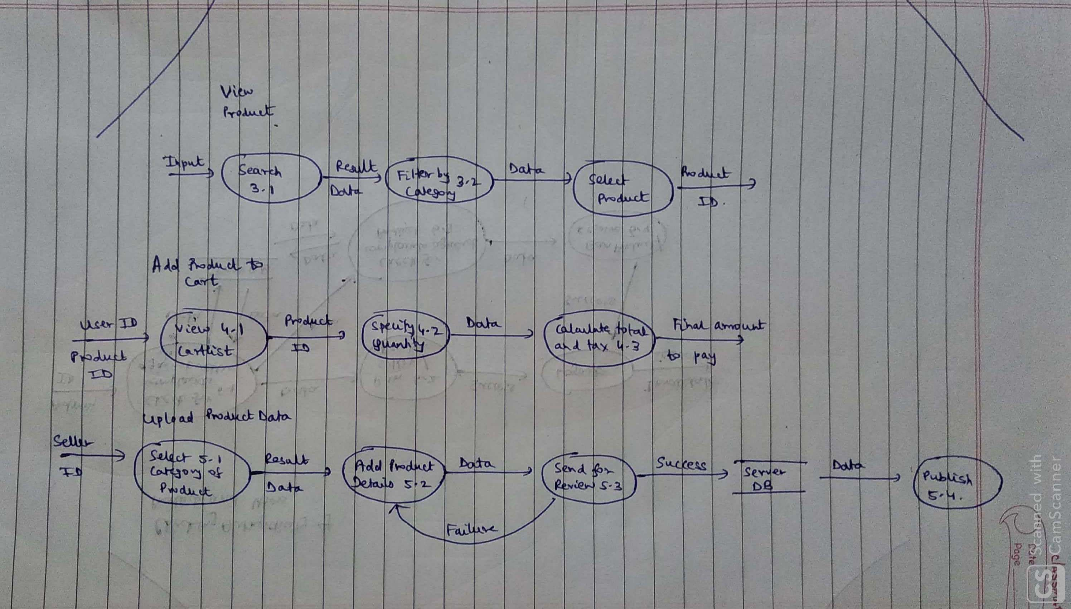

Figure 4.15: Level 1 of DFD

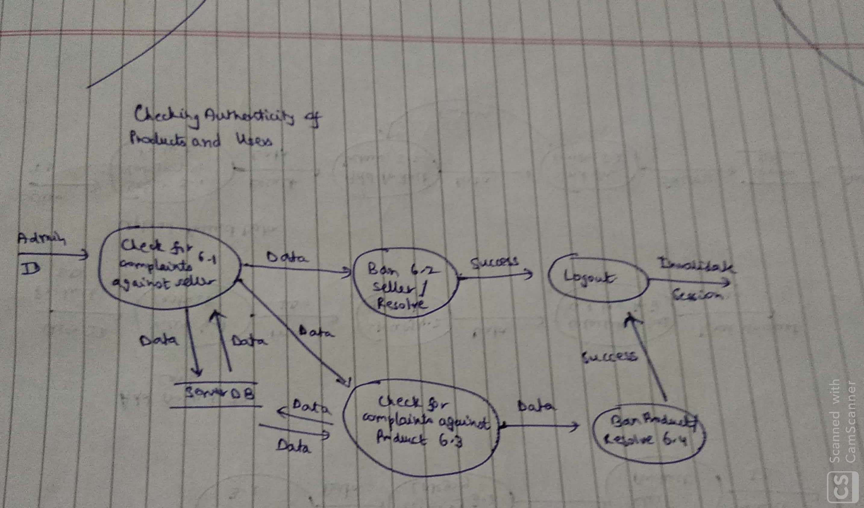

Figure 4.16: Level 1 of DFD

For our e-commerce website, we use a database with tables to store information of the buyer, vendor, product and admin. All these entities are related to another using relationships. Each of these entities have unique keys or primary keys which help identify them. The cardinality present for all of these entities is many-many.

We designed an ER Diagram for our database:

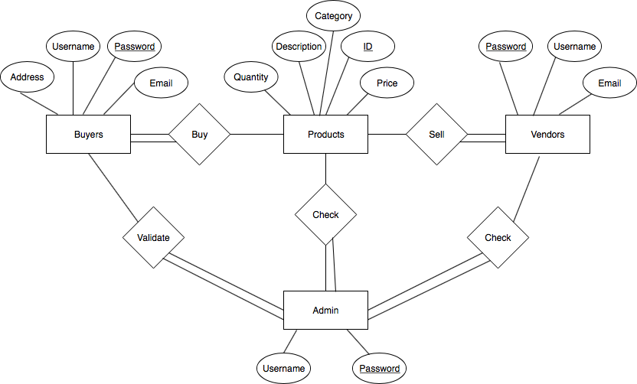

Figure 4.17: Entity Relationship Diagram

**DESIGN MODELLING**

The goal of design modelling is to produce a model or representation that exhibits firmness, commodity and delight. The requirements model should be carefully transformed into the design model in such a way such that the

* Scenario based elements are considered in Interface Design
* Flow oriented elements are considered in Component, Interface and Architectural Design
* Behavioural elements are considered in Component and Interface Design
* Class based elements are considered in Architectural and Data Design

The design modelling must follow software quality and guidelines such as it must implement all of the explicit requirements contained in the requirements model, must be a readable, understandable guide for those who generate code and for those who test and subsequently support the software and should provide a complete picture of the software, addressing the data, functional, and behavioural domains from an implementation perspective.

ARCHITECTURAL DESIGN

The software architecture of a program or computing system is the structure or structures of the system, which comprise software components, the externally visible properties of those components, and the relationships among them. Software architecture must model the structure of a system and the manner in which data and procedural components collaborate with one another.

For our e-commerce website, software architecture is important due to the following reasons:

• Representations of software architecture are an enabler for communication between all parties (stakeholders) interested in the development of our e-commerce website.

• The architecture highlights early design decisions that will have a profound

impact on all software engineering work that follows and, as important, on

the ultimate success of our e-commerce website as a functional entity.

• Architecture constitutes a relatively small, intellectually graspable model of

how the system is structured and how its components work together which helps us understand how our e-commerce website would finally function.

The Architecture Context Diagram for our e-commerce website is:

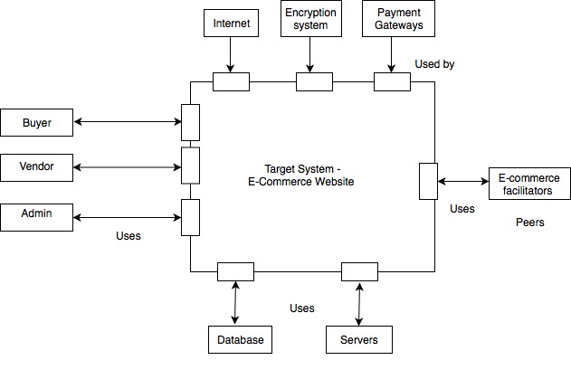

Figure 5.1: ACD Diagram of System

COMPONENT DESIGN

A component is a modular building block for computer software. A component is a modular, deployable, and replaceable part of a system that encapsulates implementation and exposes a set of interfaces. From an object oriented viewpoint, a component is a set of collaborating classes. While designing modules for our project, we try to make sure that the designs that are more amenable to change and to reduce the propagation of side effects when changes do occur. We followed some basic principles while designing components such as:

* A module (component) should be open for extension but closed for modification.
* Many client-specific interfaces are better than one general purpose interface.
* We must depend on abstractions and not on concretions.
* Classes that change together belong together.
* Classes must be designed for reuse.
* Classes that aren’t reused together should not be grouped together.

A component level design for a calculating the total cost of items in the cart:

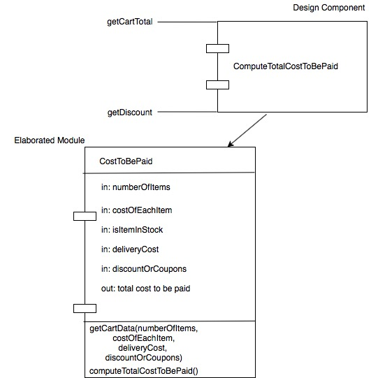

Figure 5.2: Total Cost to be paid (Component)

A component level design for a making new products available to buyers:

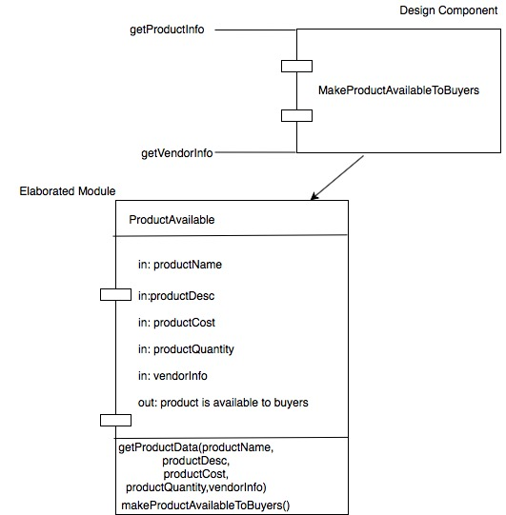Figure 5.3: Make Product Available to Buyers:(Component)

A component level design for a giving Admins information about Users and their past actions, complaints against Users:

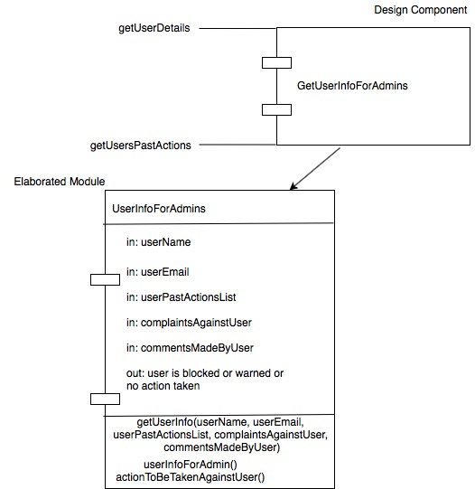

Figure 5.4: Get User Info For Admins(Component)

**USER INTERFACE DESIGN**

The interface design focuses on three rules which are:

* Place the user in control.
* Reduce the user’s memory load.
* Make the interface consistent.

The user interface should be developed after interface analysis and design is done. We use a spiral model while designing the user interface for our website since the spiral model is iterative and can continually be changed in order to meet user expectations after feedback and validation is done. While designing the user interface, user analysis, task analysis and modelling, analysis of the displayed content and analysis of the work environment is done.

The user interfaces designed for our website are:

* Login and Registration

We designed the login and registration page to be attractive and eye catching so that even new users are attracted and are inclined to make an account with us. We designed the login page to have username and password fields with an option of forgot password.

Designed UI:

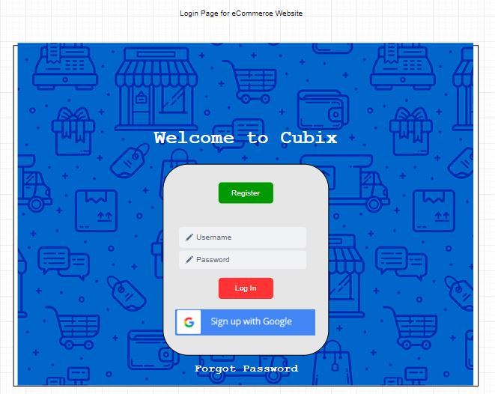

Figure 6.1: Login and Registration UI

After coding UI:

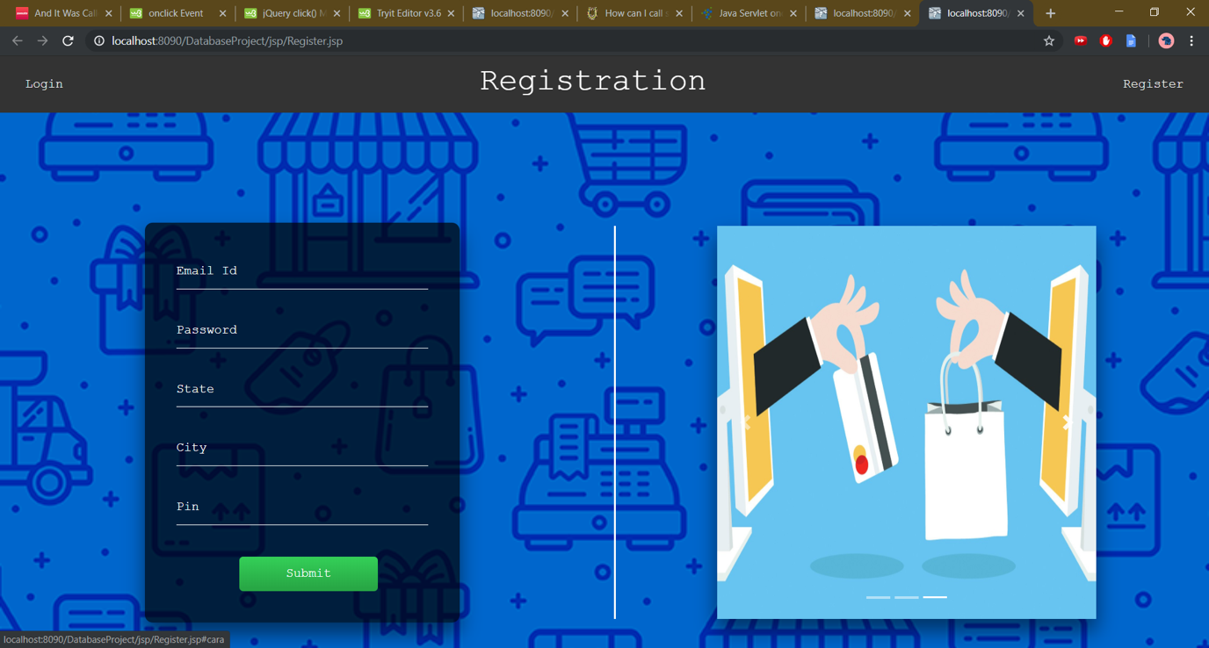

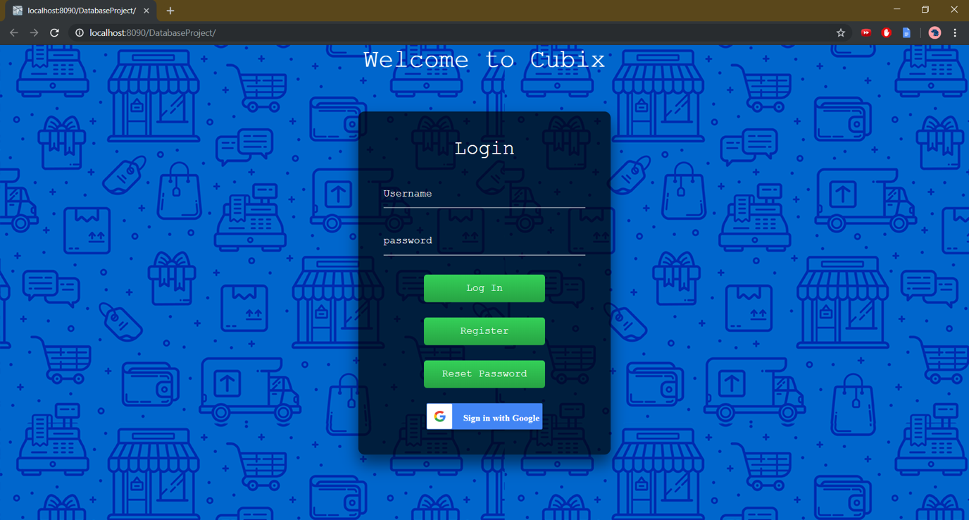

Figure 6.2: Actual UI Designed for Login and Registration

* Vendor

We designed the Vendor UI to be easy to use so that even vendors who are not that tech-savvy can upload their products to our website and quickly reach out to buyers by giving a description, picture, price and quantity. Each vendor has a username and password.

Designed UI:

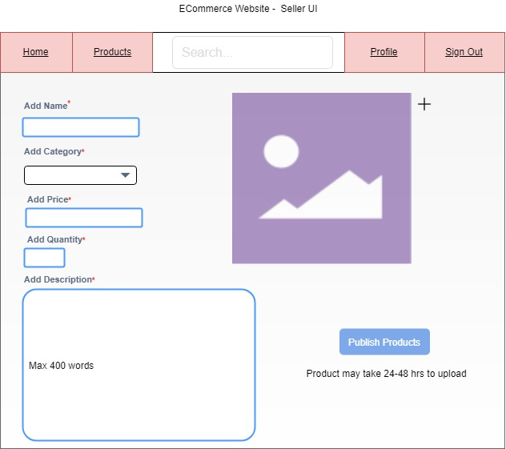

Figure 6.3: Vendor UI

After coding UI:

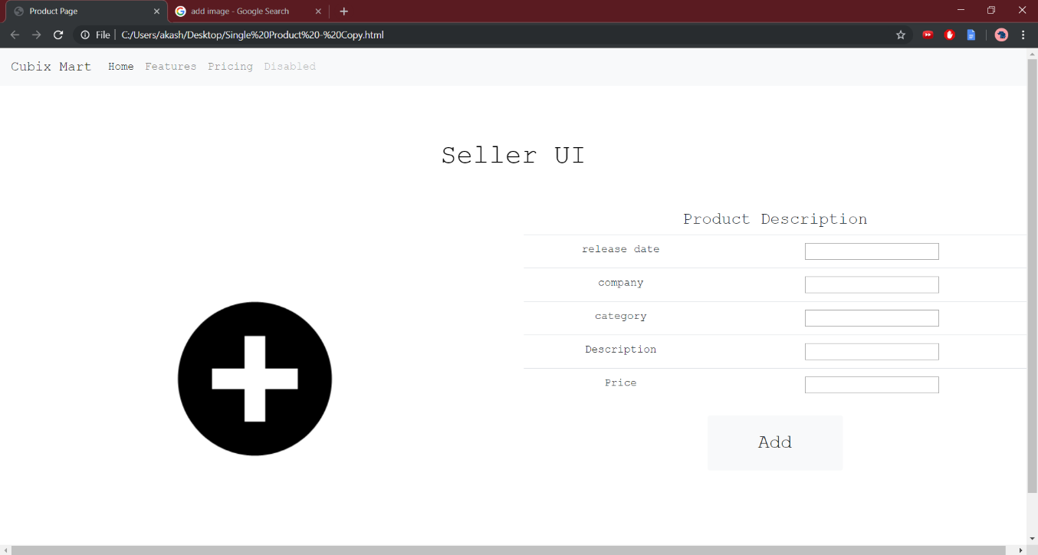

Figure 6.4: Actual UI of Vendor

* Cart

The buyer’s cart has the items which the user is about to buy. We designed the cart to be attractive and which encourages the user to make the purchase. The expected time of delivery, total amount and address to be delivered will be displayed to the user.

Designed UI:

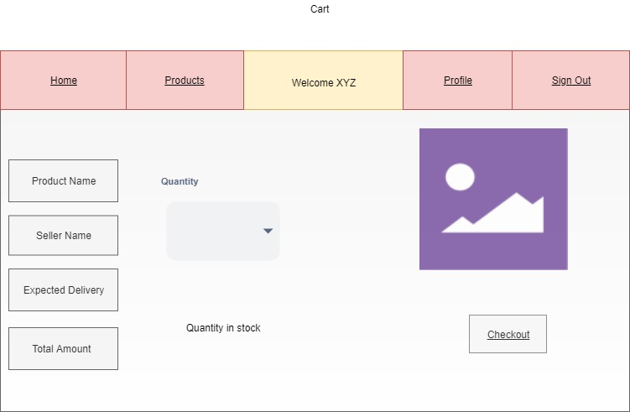

Figure 6.5 : Cart UI

After coding UI:

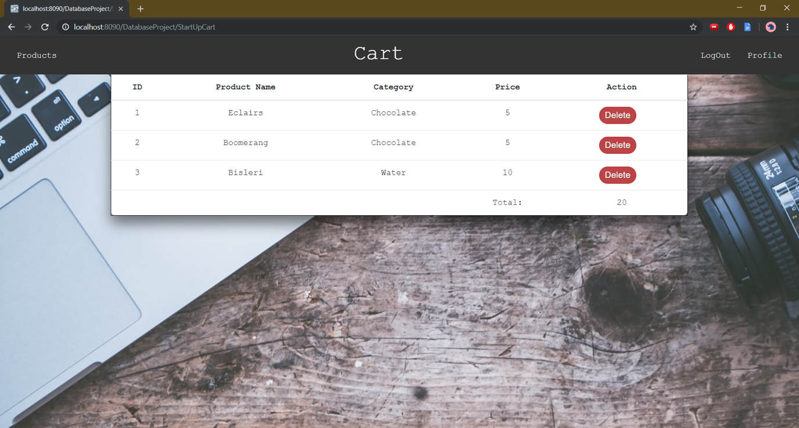

Fig 6.6: Actual Cart UI

* Buyer

We designed the buyer UI to be easy to use yet aesthetic. The buyer can choose by category or choose directly for a product through a search bar option. The various products can be listed and the buyer can select which to buy. The buyer UI is designed to encourage the user to make a purchase by adding details like past reviews and top offers etc.

Designed UI:

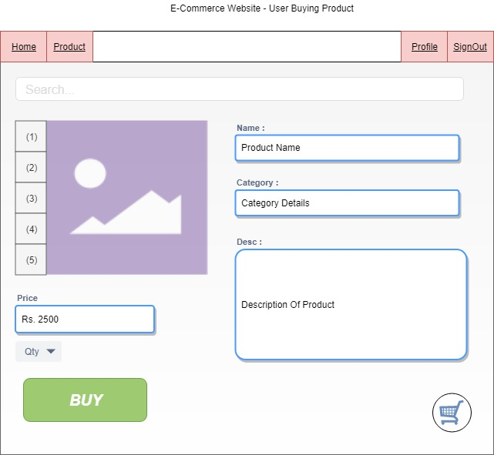

Figure 6.7: Buyer UI

After coding UI:

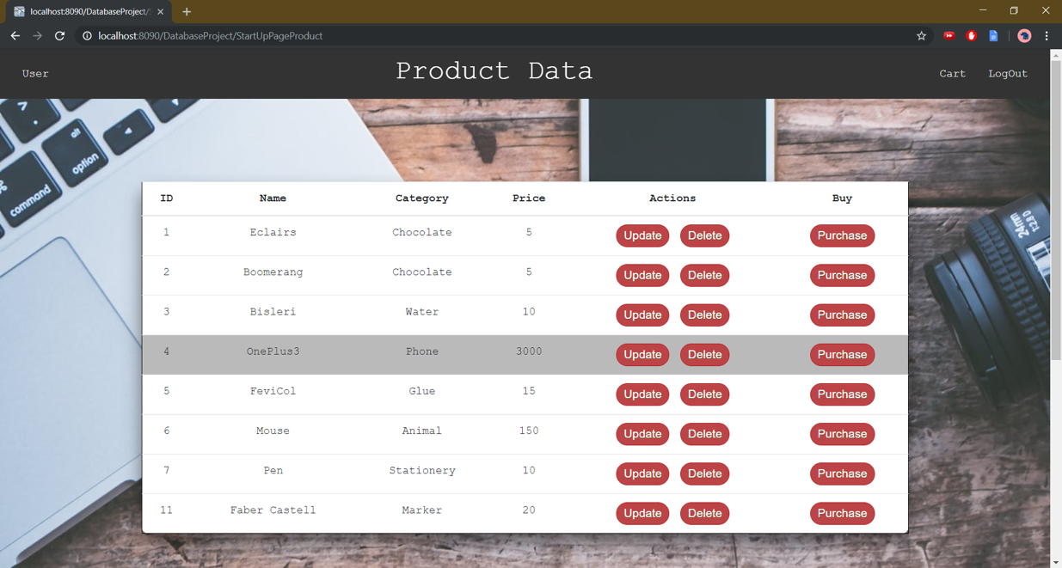

Figure 6.8: Actual Buyer UI

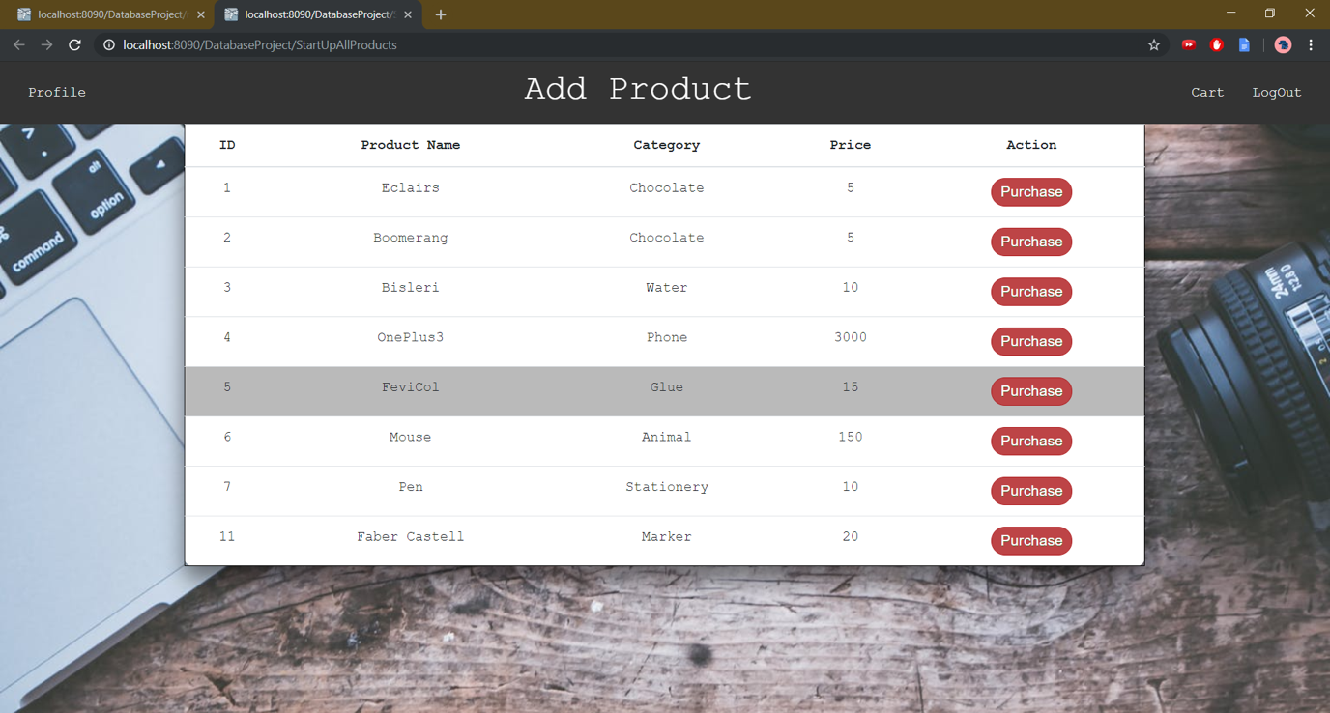

Figure 6.9: Actual Buyer UI

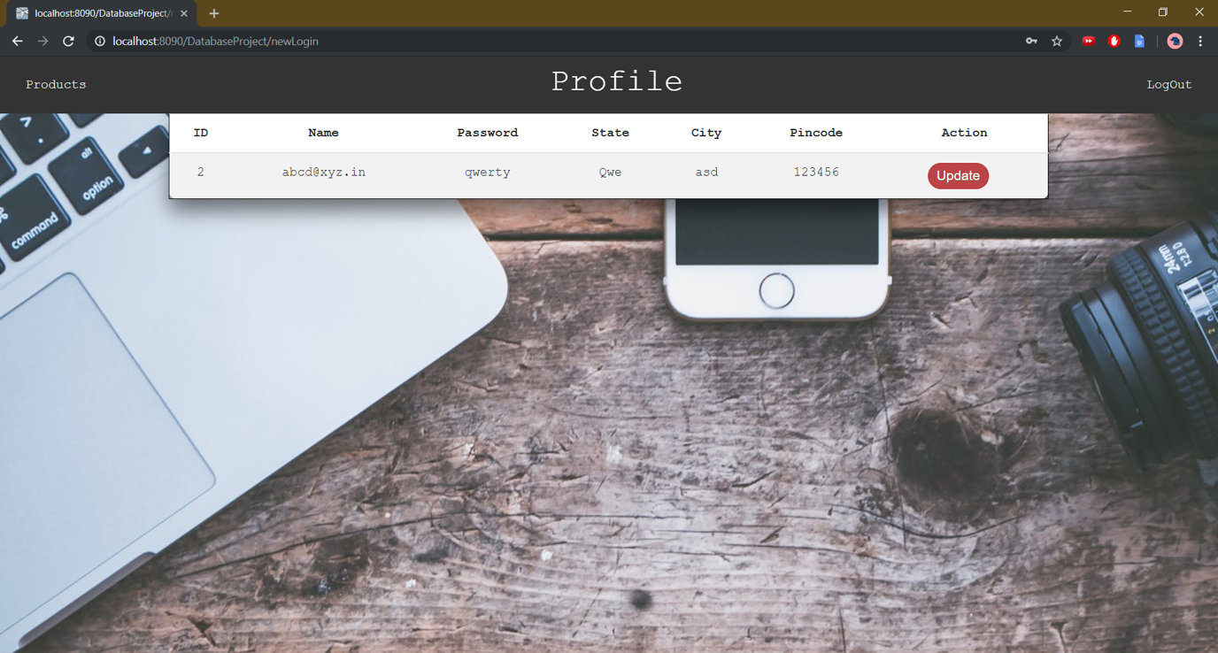

Figure 6.10: Actual Buyer UI

* Admin UI

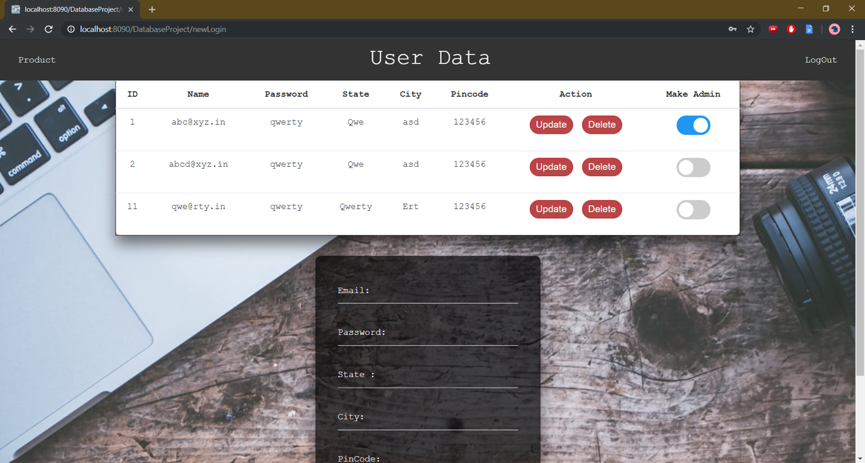

Figure 6.11 : Admin UI

**CODE FOR THE WEBSITE**

Module: Product Page

package com.godrej.daoimpl;

import java.sql.Connection;

import java.sql.PreparedStatement;

import java.sql.ResultSet;

import java.sql.Statement;

import java.util.ArrayList;

import java.util.List;

import com.godrej.dao.ProductDao;

import com.godrej.model.Product;

import com.godrej.util.DbConnection;

public class ProductDaoImpl implements ProductDao{

              private static List<Product> pdtList = new ArrayList<Product>();

              private List<Product> tempList = new ArrayList<Product>();

              public List<Product> getPdtList() {

                           return pdtList;

              }

              @Override

              public List<Product> search(int ch, String s) {

                           tempList.clear();

                           Connection conn = null;

                           Statement stmt = null;

                           try {

                                         DbConnection util = new DbConnection();

                                         conn = util.getConn();

                                         stmt = conn.createStatement();

                                         if(stmt.executeUpdate("select count(1) where exists (select * from Product)") == 1)

                                                       System.out.println("\nList Empty");

                                         else {

                                                       int flag1=0;

                                                       ResultSet rs;

                                                       switch (ch) {

                                                       case 1:

                                                                    rs = stmt.executeQuery("select * from Users Where EMAIL ='"+s+"'");

                                                                    while(rs.next()) {

                                                                                  Product product = new Product();

                                                                                  product.setProduct_Id(rs.getInt("PID"));

                                                                                  product.setProduct_Name(rs.getString("NAME"));

                                                                                  product.setProduct_Cat(rs.getString("CATEGORY"));

                                                                                  product.setProduct_Price(rs.getInt("PRICE"));

                                                                                  tempList.add(product);

                                                                                  flag1=1;

                                                                    }

                                                                    break;

                                                                    //                                                   for(Product product:pdtList)

                                                                    //                                                                 if(product.getProduct_Name().contains(s)) {

                                                                    //                                                                               tempList.add(product);

                                                                    //                                                                              ctr=1;

                                                                    //                                                                 }

                                                       case 2:

                                                                    rs = stmt.executeQuery("select * from Users Where CATEGORY ='"+s+"'");

                                                                    while(rs.next()) {

                                                                                  Product product = new Product();

                                                                                  product.setProduct_Id(rs.getInt("PID"));

                                                                                  product.setProduct_Name(rs.getString("NAME"));

                                                                                  product.setProduct_Cat(rs.getString("CATEGORY"));

                                                                                  product.setProduct_Price(rs.getInt("PRICE"));

                                                                                  tempList.add(product);

                                                                                  flag1=1;

                                                                    }

                                                                    break;

                                                                    //                                                   for(Product product:pdtList)

                                                                    //                                                                 if(product.getProduct_Cat()==s) {

                                                                    //                                                                               tempList.add(product);

                                                                    //                                                                              ctr=1;

                                                                    //                                                                 }

                                                       case 3:

                                                                    rs = stmt.executeQuery("select * from Users Where PRICE ='"+Integer.parseInt(s)+"'");

                                                                    while(rs.next()) {

                                                                                  Product product = new Product();

                                                                                  product.setProduct_Id(rs.getInt("PID"));

                                                                                  product.setProduct_Name(rs.getString("NAME"));

                                                                                  product.setProduct_Cat(rs.getString("CATEGORY"));

                                                                                  product.setProduct_Price(rs.getInt("PRICE"));

                                                                                  tempList.add(product);

                                                                                  flag1=1;

                                                                    }

                                                                    break;

                                                                    //                                                   for(Product product:pdtList)

                                                                    //                                                                 if(product.getProduct_Price()==Integer.parseInt(s)) {

                                                                    //                                                                               tempList.add(product);

                                                                    //                                                                              ctr=1;

                                                                    //                                                                 }

                                                       default: System.out.println("\nNot Found");

                                                       }

                                                       if(flag1==0)

                                                                    System.out.println("\nNo record found");

                                                       else

                                                                    return tempList;

                                         }

                           }catch(Exception e) {

                                         e.printStackTrace();

                           }

                           finally{

                                         try {

                                                       if(conn != null) {

                                                                    conn.close();

                                                       }

                                                       if(stmt != null) {

                                                                    stmt.close();

                                                       }

                                                       /*

                                                       * if(rs != null) { rs.close(); }

                                                       */

                                         } catch (Exception e) {

                                                       e.printStackTrace();

                                         }

                           }

                           return null;

              }

              @Override

              public boolean insert(Product product) {

                           int check;

                           Connection conn = null;

                           Statement stmt = null;

                           try {

                                         DbConnection util = new DbConnection();

                                         conn = util.getConn();

                                         stmt = conn.createStatement();

                                         stmt = null;

                                         stmt = conn.createStatement();

                                         PreparedStatement ps = conn.prepareStatement("insert into product values(seq_pdt.nextval,?,?,?)");

                                         if(stmt.executeUpdate("Select * from Product WHERE name = '"+ product.getProduct_Name()+"'")==0) {

                                                       ps.setString(1, product.getProduct_Name());

                                                       ps.setString(2, product.getProduct_Cat());

                                                       ps.setInt(3, product.getProduct_Price());

                                                       check = ps.executeUpdate();

                                                       if(check==1)

                                                                    return true;

                                                       else

                                                                    return false;

                                         }

                           }catch (Exception e) {

                                         e.printStackTrace();

                                         return false;

                           }finally {

                                         try {

                                                       if(conn != null) {

                                                                    conn.close();

                                                       }

                                                       if(stmt != null) {

                                                                    stmt.close();

                                                       }

                                                       /*

                                                       * if(rs != null) { rs.close(); }

                                                       */

                                         } catch (Exception e) {

                                                       e.printStackTrace();

                                         }

                           }

                           return false;

              }

              @Override

              public List<Product> update(int id, String s, int option) {

                           tempList.clear();

                           Connection conn = null;

                           Statement stmt = null;

                           try {

                                         DbConnection util = new DbConnection();

                                         conn = util.getConn();

                                         stmt = conn.createStatement();

                                         if(stmt.executeUpdate("select * from Product") >0) {

                                                       PreparedStatement ps = null;

                                                       switch(option)

                                                       {

                                                       case 1:

                                                                    ps = conn.prepareStatement("UPDATE PRODUCT SET NAME = ? WHERE PID = ?");

                                                                    ps.setString(1, s);

//                                                                 product.setProduct_Name(s);

                                                                    break;

                                                       case 2:

                                                                    ps = conn.prepareStatement("UPDATE PRODUCT SET CATEGORY = ? WHERE PID = ?");

                                                                    ps.setString(1, s);

//                                                                 product.setProduct_Cat(s);

                                                                    break;

                                                       case 3:

                                                                    ps = conn.prepareStatement("UPDATE PRODUCT SET PRICE = ? WHERE PID = ?");

                                                                    ps.setInt(1, Integer.parseInt(s));

//                                                                 product.setProduct_Price(Integer.parseInt(s));

                                                                    break;

                                                       }

                                                       ps.setInt(2,id);

                                                       ps.executeQuery();

                                         }

                           }catch(Exception e) {

                                         e.printStackTrace();

                           }finally {

                                         try {

                                                       if(conn != null && option == 5) {

                                                                    conn.close();

                                                       }

                                                       if(stmt != null && option == 5) {

                                                                    stmt.close();

                                                       }

                                                       /*

                                                       * if(rs != null) { rs.close(); }

                                                       */

                                         } catch (Exception e) {

                                                       e.printStackTrace();

                                         }

                           }

                           return null;

              }

              @Override

              public boolean delete(int id) {

                           Connection conn = null;

                           Statement stmt = null;

                           try {

                                         DbConnection util = new DbConnection();

                                         conn = util.getConn();

                                         stmt = conn.createStatement();

                                         String sql = "DELETE from PRODUCT where PID ="+id;

                                         int i = stmt.executeUpdate(sql);

                                         if(i == 1)

                                                       return true;

                           }catch(Exception e) {

                                         e.printStackTrace();

                           }finally {

                                         try {

                                                       if(conn != null) {

                                                                    conn.close();

                                                       }

                                                       if(stmt != null) {

                                                                    stmt.close();

                                                       }

                                                       /*

                                                       * if(rs != null) { rs.close(); }

                                                       */

                                         } catch (Exception e) {

                                                       e.printStackTrace();

                                         }

                           }

                           return false;

              }

              @Override

              public List<Product> display() {

                           tempList.clear();

                           Connection conn = null;

                           Statement stmt = null;

                           try {

                                         DbConnection util = new DbConnection();

                                         conn = util.getConn();

                                         stmt = conn.createStatement();

                                         ResultSet rs = stmt.executeQuery("Select * from PRODUCT");

                                         while(rs.next()) {

                                                       Product product = new Product();

                                                       product.setProduct_Id(rs.getInt("PID"));

                                                       product.setProduct_Name(rs.getString("NAME"));

                                                       product.setProduct_Cat(rs.getString("CATEGORY"));

                                                       product.setProduct_Price(rs.getInt("PRICE"));

                                                       tempList.add(product);

                                         }

                                         if(tempList.isEmpty())

                                                       return null;

                                         else

                                                       return tempList;

                           }catch(Exception e) {

                                         e.printStackTrace();

                           }finally {

                                         try {

                                                       if(conn != null) {

                                                                    conn.close();

                                                       }

                                                       if(stmt != null) {

                                                                    stmt.close();

                                                       }

                                                       /*

                                                       * if(rs != null) { rs.close(); }

                                                       */

                                         } catch (Exception e) {

                                                       e.printStackTrace();

                                         }

                           }

                           return null;

              }

}

**COST ESTIMATION FOR THE PROJECT**

While estimating the cost for our website, we took into consideration the following points:

* Project scope and importance to users
* Number of functionalities and features developed
* Number of users who would potentially use our website
* Cost incurred by rival websites in development
* Number of hours put in
* Number of techniques and skills developed while developing
* Risk incurred while developing

We made use of function point estimation which can be used effectively as a means for measuring the functionality delivered by a system. Function points are derived using an empirical relationship based on countable (direct) measures of software's information domain and assessments of software complexity

Information domain values are defined in the following manner:

* Number of external inputs (EIs)
* Number of external outputs (EOs)
* Number of external inquiries (EQs)
* Number of internal logical files (ILFs)
* Number of external interface files (EIFs)

**Information Weighting Factor**

**Domain Value Count Simple Average Complex**

External Inputs _____ x 3 4 6 = _____

External Outputs _____ x 4 5 7 = _____

External Inquiries _____ x 3 4 6 = _____

Internal Logical Files _____ x 7 10 15= _____

External Interface Files _____ x 5 7 10 = _____  
**Count total** ________

Given the following values, compute function point when all complexity adjustment factor (CAF) and weighting factors are average.

* The User Input for our project is broken into inputs coming from the buyer, vendor and admin. The maximum inputs a buyer or a vendor gives while going through their journey in our ecommerce website is 20 and 30 respectively. The admin has to give 40 inputs since he may input more information to find data for specific users or products to check legitimacy.

User Input = 20+30+40=90

* The User Output is the output which the website gives to the user. The buyer and vendor both will get an equal amount of output (15) in terms of actions performed in one journey on the website. The output provided to an admin can be results of the information he wants to check like user or product stats and legitimacy. Thus admin will get a few outputs more (20).

User Output = 15+15+20=50

* User Inquiries are the data and information which the user can change to personalize his experience on our website. This includes a range of setting preferences, credit card information, address change, profile updation and various other activities like adding favorite products and categories.

User Inquiries = 50

* The User Logical files include the number of tables within a database which is used when a user or admin queries the database. The various tables can be buyers, vendors, products, admins etc.

User Logical Files = 8

* External Interfaces are the number of forward client facing interfaces . These include a login, registration, vendor, buyer and cart.

External Interface = 5

**Complexity adjustment factor is significant**

Scale = 4.

F = 14 * 4 = 56

(Complexity Adjustment Factor) CAF = 0.65 + (0.01 * 56) = 1.21

As weighting factors are also significant(complex) hence we will multiply each individual function point to corresponding values given in the table.

UFP = (90*6) + (50*7) + (50*6) + (8*15) + (5*10) = 1360

Function Point = 1360 * 1.21 = 1645.60

Burdened Labor Rate = Rs.35400 per month per employee

This amount is arrived at taking into consideration the number of hours put in per month, the number of lines of code written, the number of pages of documentation done, the different models designed, the functionalities and features designed.

**TEST CASES**

While testing our E-Commerce website we examine the following quality dimensions:

* Content

The content of our website must be evaluated at both a syntactic and semantic level. Each webpage should have no ambiguity present and all webpages must be consistent.

* Function

We test each function and journey in our website for correctness, instability, and general conformance to appropriate implementation standards (Javascript, Java, HTML, PHP language standards)

* Usability

Each category of user is supported by the interface and can learn and apply all required navigation syntax and semantics offered by our website.

* Navigability

This is tested to ensure that all navigation syntax and semantics are exercised to uncover any navigation errors (e.g., dead links, improper links, erroneous links) in our website which if not uncovered may lead to the website crashing.

* Performance

This is tested under a variety of operating conditions, configurations, and loading to ensure that the system is responsive to user interaction and handles extreme loading without unacceptable operational degradation. The e-commerce website must handle varying degree of load without degrading the user experience.

* Interoperability

This is tested to ensure that the e-commerce website properly interfaces with the database used so that the retrieval and transmission of data is smooth and doesn’t lead to performance degradation.

* Security

This is tested by assessing potential vulnerabilities and attempting to exploit each. Any successful penetration attempt is deemed a security failure. In our e-commerce website, potential security issues could be linked to hacking of an account, cross-site scripting, SQL injection, DoS attack etc. Also, since a gateway portal is present, security of payment details must be robust.

OUR TESTING STRATEGY

* The content model for the e-commerce website is reviewed to uncover errors.
* The interface model is reviewed to ensure that all use cases can be accommodated.
* The design model for the e-commerce website is reviewed to uncover navigation errors.
* The user interface is tested to uncover errors in presentation and/or navigation

mechanics.

* Functional components are unit tested.
* Navigation throughout the architecture is tested.
* The e-commerce website is implemented in a variety of different environmental configurations and is tested for compatibility with each configuration.
* Security tests are conducted in an attempt to exploit vulnerabilities in the e-commerce website or within its environment.
* Performance tests are conducted.
* The e-commerce website is tested by a controlled and monitored population of end users; the results of their interaction with the system are evaluated for content and

navigation errors, usability concerns, compatibility concerns, and website

security, reliability, and performance

We performed content testing, user interface testing, component level testing, navigation testing, configuration testing, security testing for our website. We plan to undergo performance testing as well as get feedback for the full website from end users which can further improve the quality of our website.

The test cases for Login, Registration and Security are:

1. **Login and Registration**

|  |  |  |  |  |  |  |  |  |  |
| --- | --- | --- | --- | --- | --- | --- | --- | --- | --- |
| **Test case id** | **Test cases** | **Priority** | **Precondition** | **Input test data** | **Steps to be executed** | **Expected results** | **Actual results** | **Pass/fail** | **Comment** |
| 1 | Test if user is able to login successfully | A | User must be registered already | Correct username  Correct password | 1)Enter input  (correct)  Username and password on the respective fields  Click submit and login | User must successfully login to the web page | User successfully logs in | Pass |  |
| 2 | Test if unregistered users are not able to login to the site | A | Security and database linking of username and password should be in place | Incorrect usernameIncorrect password | 1)Enter input  (incorrect)  username and password on the respective fields  Click submit and login | Proper error must be displayed and prompt to enter login again | User is not able to login and output shown on the screen displaying invalid credentials. | Pass |  |
| 3 | Test if Username/ Password is wrong | A | Security and database linking of username and password should be in place | Incorrect username and/or password | 1)Enter input  (incorrect)  username and password on the respective fields  Click submit and login | Proper error must be displayed and prompt to enter login again | User is not able to login and output shown on the screen displaying invalid credentials. | Pass |  |
| 4 | Test if Username is already used in the registration page before | A | Security and database linking of username and password should be in place | Username and password | 1)Enter input  username and password on the respective fields  Click register | Proper error must be displayed and prompt to try to register again | Username checking is not enabled. | Fail |  |
| 5 | Test if already registered users cannot make a new account using same email id | A | Security and database linking of registered password should be in place | Email Id | 1)Enter input  Click register | Proper error must be displayed and prompt to try to register again (email id already used. | Check of same email use is not done | Fail |  |
| 6 | Test if Password includes Capital, number, special character and at least 8 characters in length | A | Security and database linking of registered password should be in place | Password and Username | 1)Enter input  Click register | Proper error must be displayed and prompt to try to register again | User is not able to register and output shown on the screen saying password doesn’t meet security level needed | Pass |  |
| 7 | Test if Captcha is implemented to tackle bots at time of registration | A | Security and database linking of registered password should be in place | Captcha input | 1)Enter Captcha input  Click register | Proper error must be displayed and prompt to try to register again (captcha not successful | Captcha not enabled | Fail |  |
| 8 | Test if Forgot Password is implemented | A | Security and database linking of registered password should be in place | Username/ Email Id to retrieve forgotten password | 1) Enter username and/or email id. | Email is sent to reset password | User cannot reset the password | Fail |  |
| 9 | Test if User tries to login after registering but hasn’t verified email address | A | Security and database linking of registered password should be in place | Verification from email | 1) Click verification | Email is sent to verify account | Verification cannot be sent | Fail |  |
| 10 | Test if incorrect password is inputted more than 3 times then account is locked for 1 hour | A | Security and database linking of registered password should be in place | Username and password | 1) Input the password and username and click login | Email is sent regarding suspicious usage | Account locking not done | Fail |  |

**2) Security**

|  |  |  |  |  |  |  |  |  |  |
| --- | --- | --- | --- | --- | --- | --- | --- | --- | --- |
| **Test case id** | **Test cases** | **Priority** | **Preconditions** | **Input test data** | **Steps to be executed** | **Expected results** | **Actual results** | **Pass/fail** | **Comments** |
| 1 | Test if User can access cart without logging in  (Cookies, session and cache validation) | A | User must be logged in already  Or have visited the site before on a personal comp. | correct username,  correct password,  saved cookies | Directly run cart URL along with personal ID number | User will be shown a message and redirected to error page | User opens cart page successfully | Fail |  |
| 2 | Test if user can access cart if login is successful | A | User must be registered already and have logged in with a verified account | Correct username,  correct password | Verify account and login successfully and proceed to cart | Cart will be shown | User s shows the cart page with all products that were added by them | Pass |  |
| 3 | Test if user can copy and paste password  (password sorting and hashing) | B | User must be registered already and have logged in with a verified account | Correct credentials | User might try to copy and paste password to login in the future | Password should not be allowed to be copied from the password field | Password will not be copied | Pass |  |
| 4 | Test if entry into password field is encrypted for verification | B | User must be on the login page and already have a pre-existing account | Correct credentials | User will type in their password and press login | Password should be encrypted before account verification so that a level of security is added to the user account | Password is passed as is with no level of encryption | Fail |  |
| 5 | Test if user can see the password while it is being typed in the password text field | B | User must be in the process of either registering a new account or logging in an existing account | Correct credentials | User must be competent enough to check if his password Is visible or not | Password should not be seen | Password will be shown | Fail |  |
| 5 | Test if password can be copied as plaintext or encrypted using security protocols | B | User must be in the process of either registering a new account or logging in an existing account | Correct credentials | User might try to copy and paste password to login in the future | User inputs in password field are to be encrypted and then transferred | No such encryption takes place | Fail |  |
| 6 | Test if user can run other scripts on the web page  (SQL injection and html injection) | A | User has access to any text field on the website from a verified account | A verified account and some technical knowledge | If user has technical knowledge of the website and its working, they can inject scripts into its working | Any entry is not to be treated as an executable sentence but as a text only input | No script is allowed to run from text fields due to several security protocols in place | Pass |  |
| 7 | Test if only verified users are allowed to buy from the website  (Admin verification) | C | User must have registered into the website with correct credentials | Valid information on the registration page | Admin must validate the account information for the user to gain access | User can purchase items after having been validated by the admin | User is not shown the purchase button until validation by administrators. | Pass |  |
| 8 | Test if only verified users are allowed to login into the website | C | User must have registered into the website with correct credentials | Valid information on the registration page | Admin must validate the account information for the user to gain access | User can only access the website after having been validated by the admin | User is allowed access into the website without validation. | Fail |  |

**PROJECT TEAM MANAGEMENT**

For effective software management, we focused on the people, product, process and

project. We focused on the end users who would use our product and the stakeholders.

The people involved include the team members who analyse the problem, define the

requirements, design the model, develop the website, test the website and assure the

stakeholders that quality of the website has been maintained. For our e-commerce website

development, we used the following steps:

* We defined the problem statement as well as the features and functionalities which our

website should contain.

* We individually stated the requirements, functions for every module and then compiled

them.

* We selected the model for every model after deliberation and made various analysis

and design models to help understand the flow of data, the various classes involved, the

attributes, use cases and the state of various modules as the website operates.

* We developed the code, keeping in mind the standards and guidelines which must be

adhered to such as code readability, maintainability, re-usability.

* We designed various test cases for modules such as login, registration, security and

tested the website exhaustively to see if the website passes or fails for each test case.

* We estimated the cost of our project depending on the lines of code, level of complexity,

time involved and estimated the cost per employee.

For our project, we managed the work in the following way:

* Problem Statement, Functional and Non Functional Requirements – Navid, Preyas, Akash, Ayush
* Requirements, Softwares Used and Software Models Used – Navid, Preyas, Akash, Ayush
* Analysis Modelling - Navid, Preyas, Akash, Ayush
* Design Modelling – Navid, Ayush
* User Interface Design - Navid, Preyas, Akash, Ayush
* Frontend Design – Navid, Preyas, Akash, Ayush
* Backend Coding –Akash, Preyas, Navid, Ayush
* Frontend Coding –Preyas, Akash
* Cost and Time estimation – Navid, Ayush
* Testing - Navid, Preyas, Akash, Ayush
* Future Improvements – Navid, Ayush

**FUTURE SCOPE OF IMPROVEMENT**

We discussed and outlined certain features and functionalities which could be added in the future:

* A personalized online shopping page curated to meet each user’s needs depending on the category chosen. This module would use artificial intelligence and machine learning to know learn what the user’s preferences are based on past choices.
* Adding a video feature for vendors wherein they could upload videos of their products. This would be in addition to the current photo and description currently in use.
* Live chat support - Live Chat (ChatBot for Ecommerce) feature would help our e-commerce platform to convert potential customer in real customer. It offers advice to help the customer make the purchase and increase conversion rate. It helps in increasing the sales opportunity and serve customers with the greater experience.
* Real Time Order Tracking option
* Augmented Reality View – Augmented reality view helps the customer visualize online products using their cameras. It gives an interactive experience in the real world and helps the customers to imagine products in their own room. It’s a perfect blend of reality and virtual reality. It is used in saving cost and reducing risks.
* Adding Multiple Language options
* Social Media Integration - Social media integration helps in maintaining all your social media accounts like Facebook, LinkedIn, Twitter, Instagram and many more under one platform. It allows you to share one post on multiple platforms. It boosts the marketing strategies and saves cost. It’s considered to be one of the most time-saving and cost-effective technology.
* Offer Smart Search Option: – Optimizing the search bar and assisting the customer to find what they are looking for. It can become a powerful tool for conversions. One can also store customer search history and encourage the businesses to provide with a personalized offer for frequent visitors. It’s an effective way to increase sales for our e-commerce website.